Megan Pokal
DSC 650 Big Data
Nasheb Ismaily
January 18, 2026

Objective 1 – Conceptual Foundations:

Watch the instructor-led video and write 3 to 4 paragraphs. https://youtu.be/YyWoTZOkDSE

The driver program runs the Spark application and creates the execution plan and coordinates the overall job. The cluster manager allocates CPU and memory resources for Spark but does not run the work itself. Worker nodes host executors, which run the actual tasks in parallel and perform the main data processing work.

RDD are Sparks core data structure, representing distributed data with built-in fault tolerance through lineage, allowing lost data to be recomputed if a worker fails. Spark provides higher-level abstractions like Data Frames and Datasets, which organize data in rows and columns and enable query optimizations through the Catalyst optimizer. Spark uses lazy evaluation and in-memory processing, meaning in building a logical plan and executes it only when an action is called.

Hadoop MapReduce writes intermediate results to HDFS at every stage, causing repeated disk reads and writes, which makes multi-stage jobs slow and inefficient. Spark uses a DAG-based execution plan and keeps the data in memory, writing to disk only when necessary, greatly reducing I/O and improving performance.

Comparing Spark and Hadoop MapReduce, Spark uses a driver-based architecture where the driver requests resources from a cluster manager, which allocates executors on worker nodes to run tasks in parallel. Executors process data in memory, report task progress or failures back to the driver, and enable fault tolerance by allowing failed tasks to be resubmitted. Spark can run on multiple platforms, but the core components remain the same.

Spark applications are distributed, they’re fault-tolerant and highly parallelized.

Objective 2 – Running SparkPi with PySpark:

1. Environment Initialization

ssh -L 9870:localhost:9870 -L 8088:localhost:8088 -L 8080:localhost:8080 -L 18080:localhost:18080 -L 16010:localhost:16010 -L 8983:localhost:8983 -L 8443:localhost:8443 meganpokal27@35.236.15.189

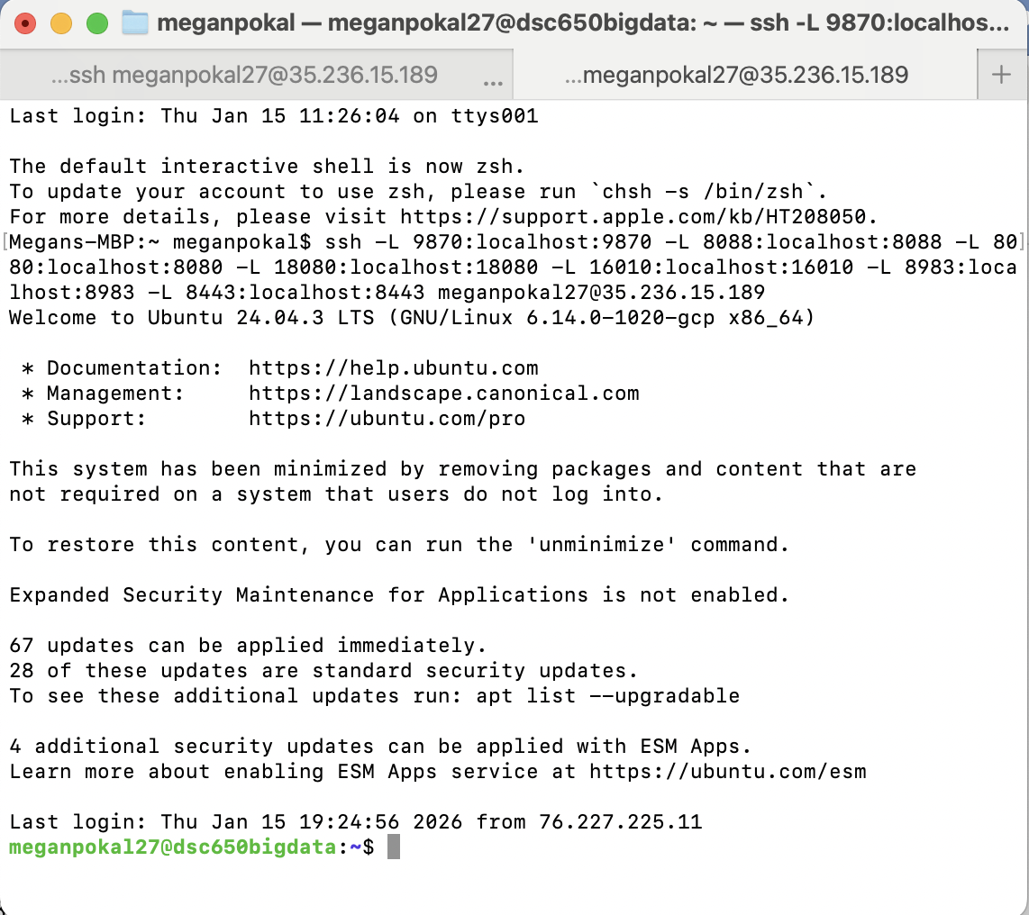

- As you did in the Week 2 and Week 3 assignments, begin by navigating to the appropriate directory:
- cd dsc650-infra/bellevue-bigdata/hadoop-hive-spark-hbase
- Start your Docker containers:
- docker-compose up -d
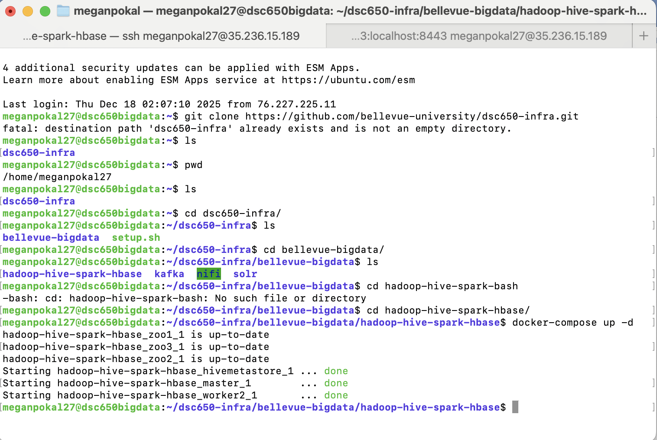
- Access the master container:
- docker-compose exec master bash

Into bash-5.0# spark-submit --class org.apache.spark.examples.SparkPi \
--master yarn \
--deploy-mode client \
--driver-memory 2g \
--executor-memory 1g \
--executor-cores 1 \
$SPARK_HOME/examples/jars/spark-examples*.jar \
10

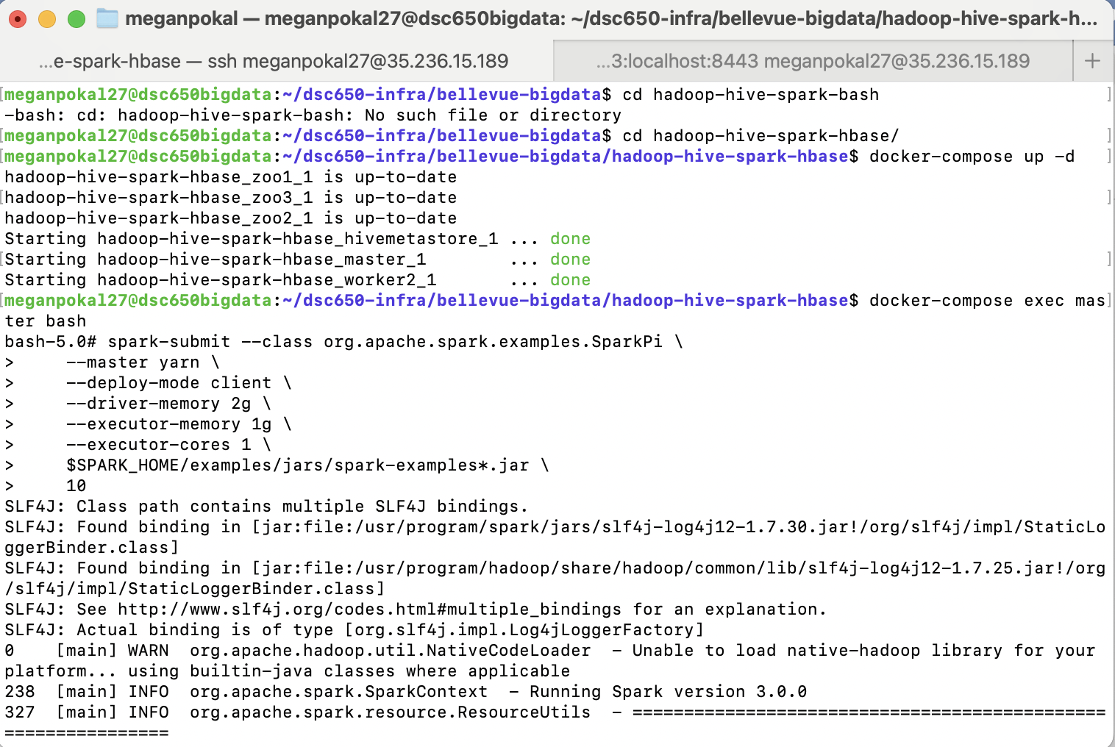
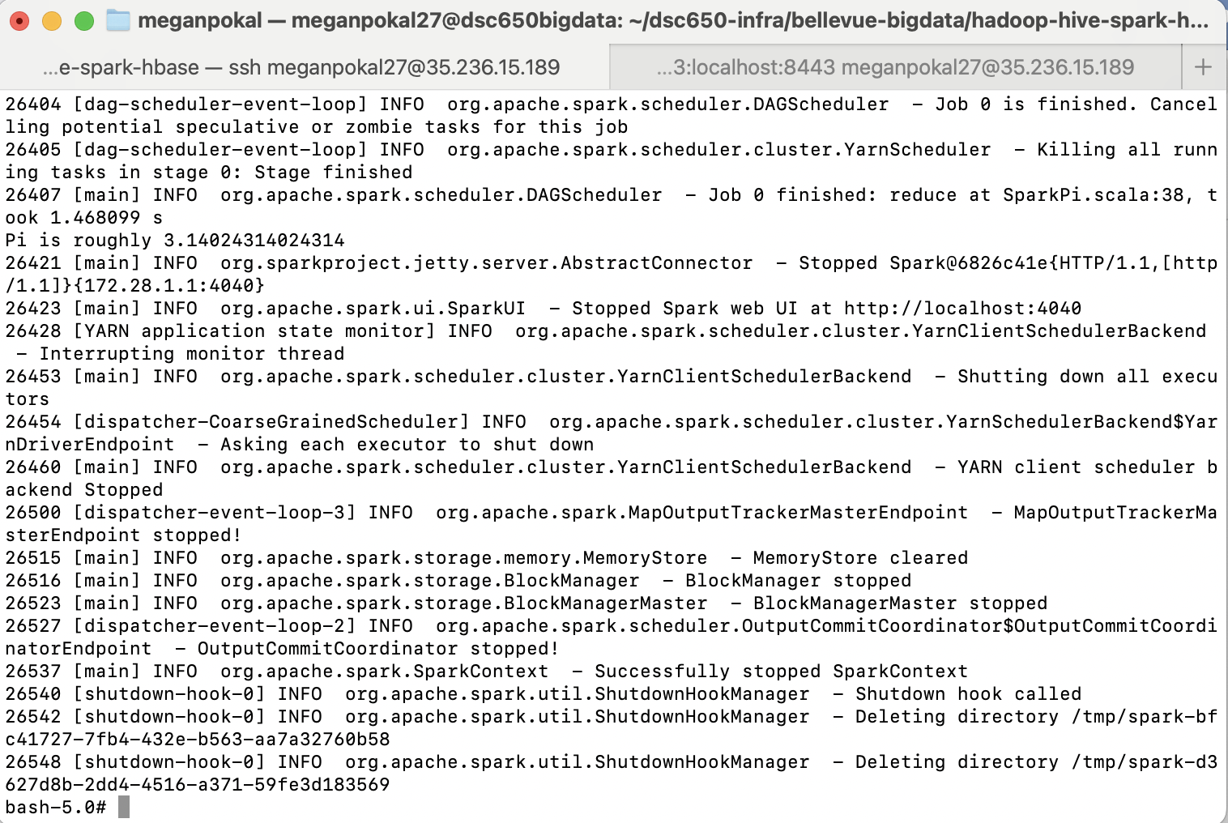

I ran the SparkPi example using spark-submit and the result is only a approximation of pie “ Pi is roughly 3.14024314024314” because spark estimates pie using random generated points instead of calculating the exact value.

The code did run properly.

Objective 3 – Spark Scala Shell:

$SPARK_HOME/bin/spark-shell --master yarn --driver-memory 2g --executor-memory 1g --executor-cores 1
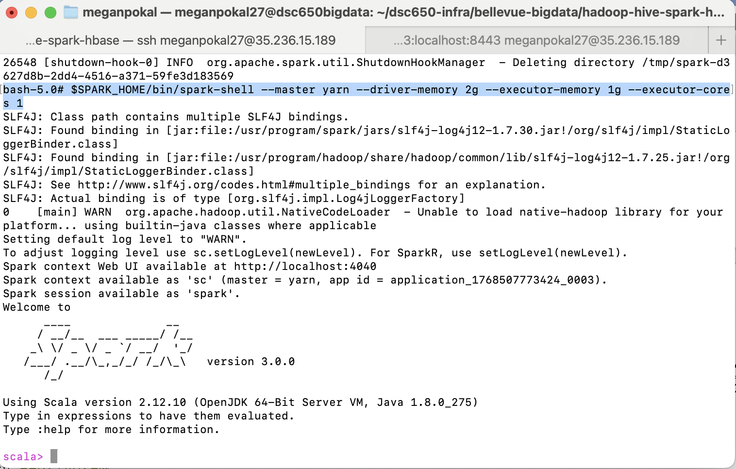

2. Generating and Printing Random Numbers in the Scala Shell

Execute the following commands in the Spark Scala shell:
val numNumbers = 10000
val numbers = (1 to numNumbers).map(_ => scala.util.Random.nextInt(1000))
val numbersRDD = sc.parallelize(numbers)
numbersRDD.take(100).foreach(println)
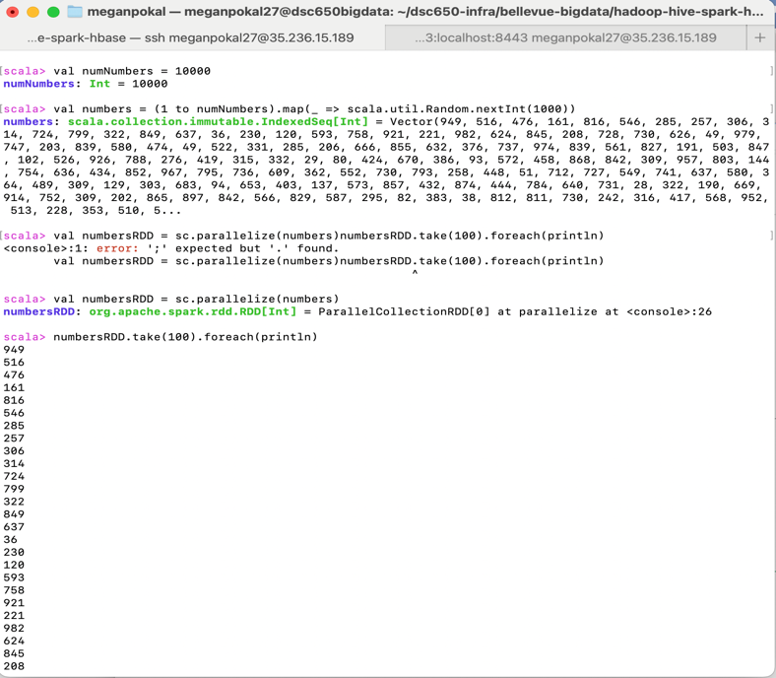

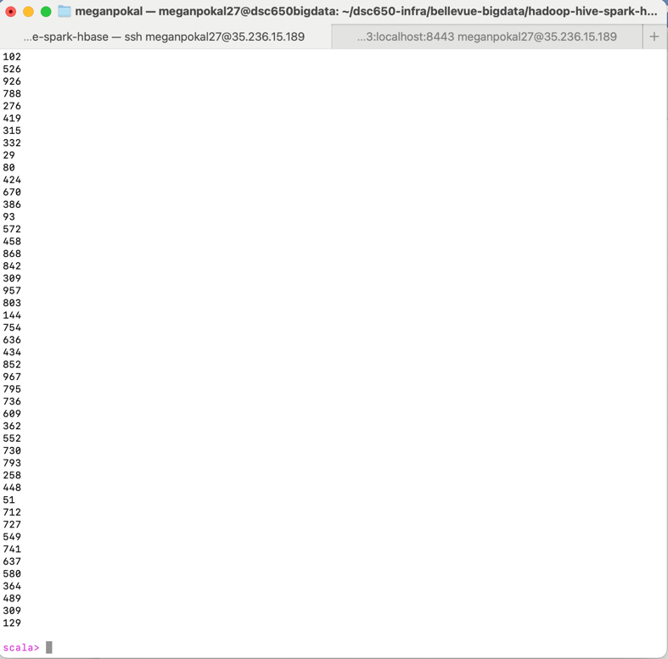

This code will generate 10,000 random numbers and convert them into a Spark RDD using parallelize and distribute the date across the Spark cluster. Spark splits the numbers into partitions, so they can be processed at the same time, which makes it easier to handle large datasets faster and more efficient.

Objective 4 – Custom Transformation with Scala:

1. Generating and Transforming Random Sentences in the Scala Shell

Generate random sentences and apply a transformation of your choice:
val numberOfSentences = 1000
val words = List("apple", "banana", "cherry", "date", "elderberry", "fig", "grape", "honeydew")
val sentences = (1 to numberOfSentences).map(_ => scala.util.Random.shuffle(words).take(scala.util.Random.nextInt(6) + 1).mkString(" ") + ".")
val sentencesRDD = sc.parallelize(sentences)

val transformedSentences = sentencesRDD.map(sentence =>
| sentence.toUpperCase + " (WORDS: " + sentence.split(" ").length + ")"
| )

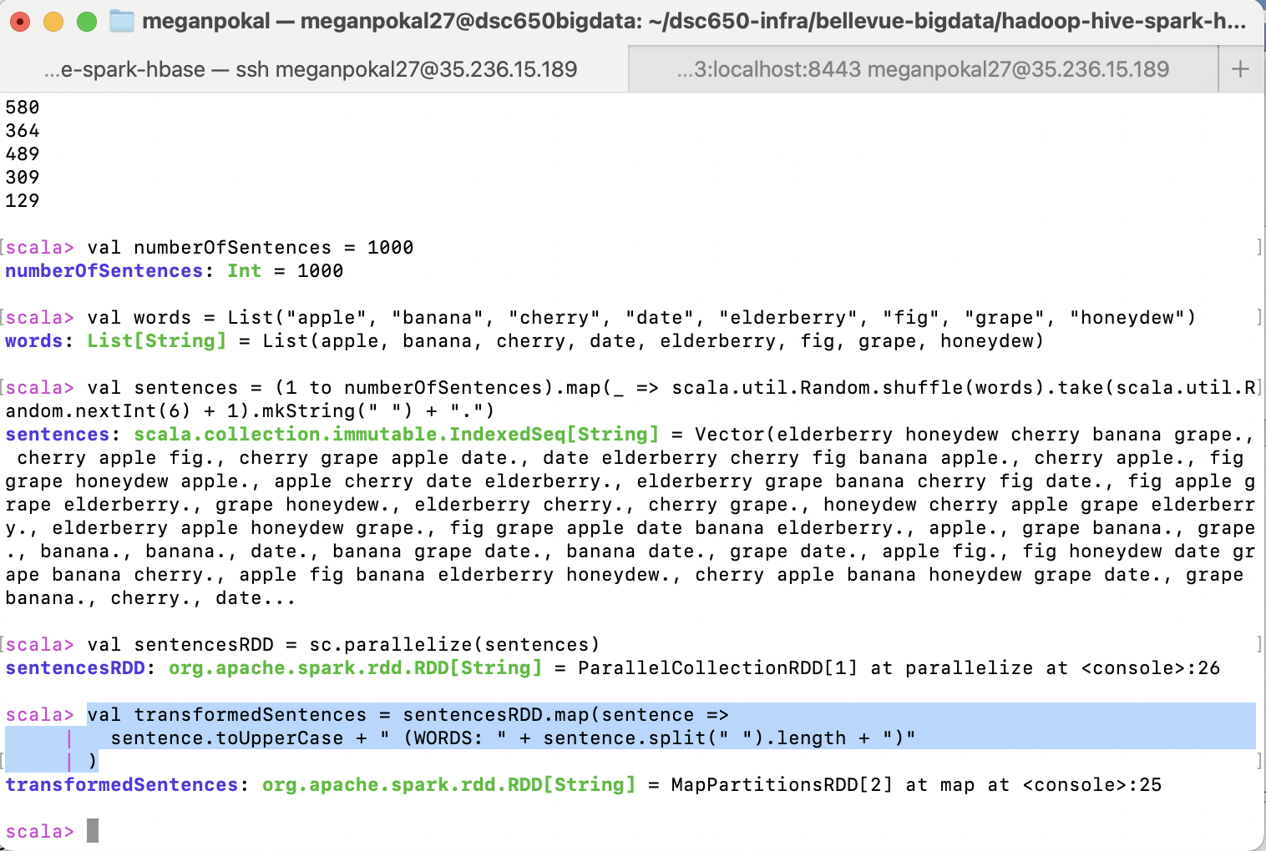

transformedSentences.take(100).foreach(println)

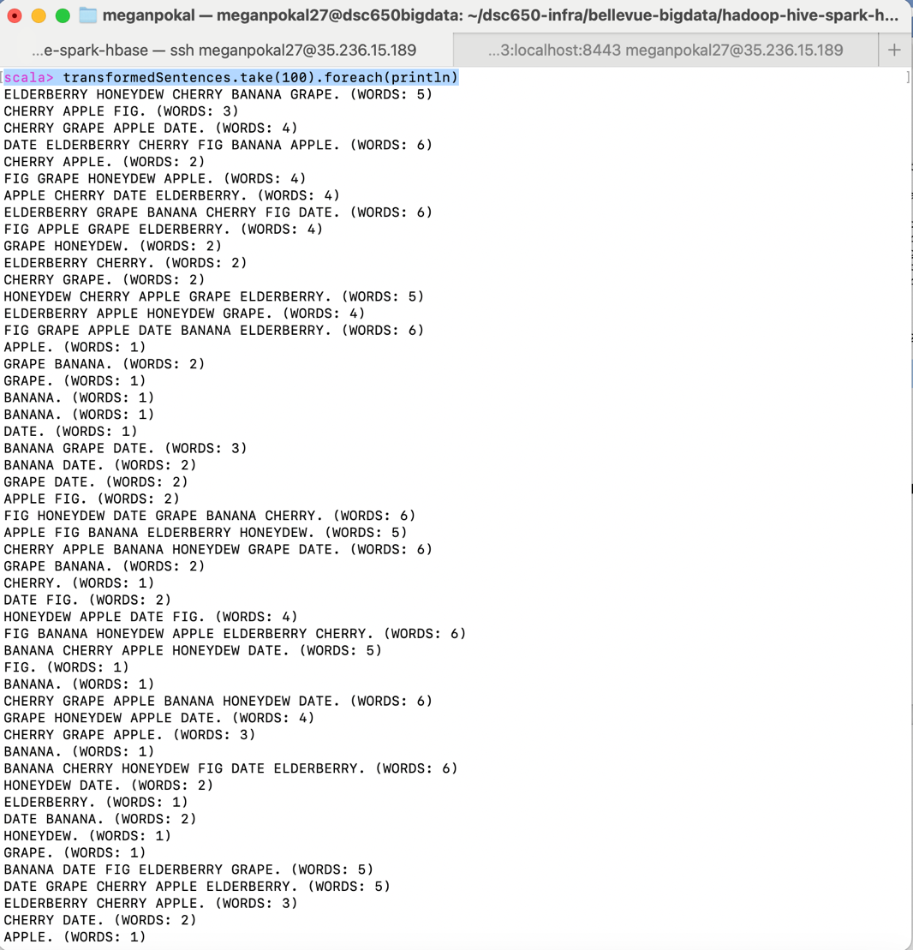

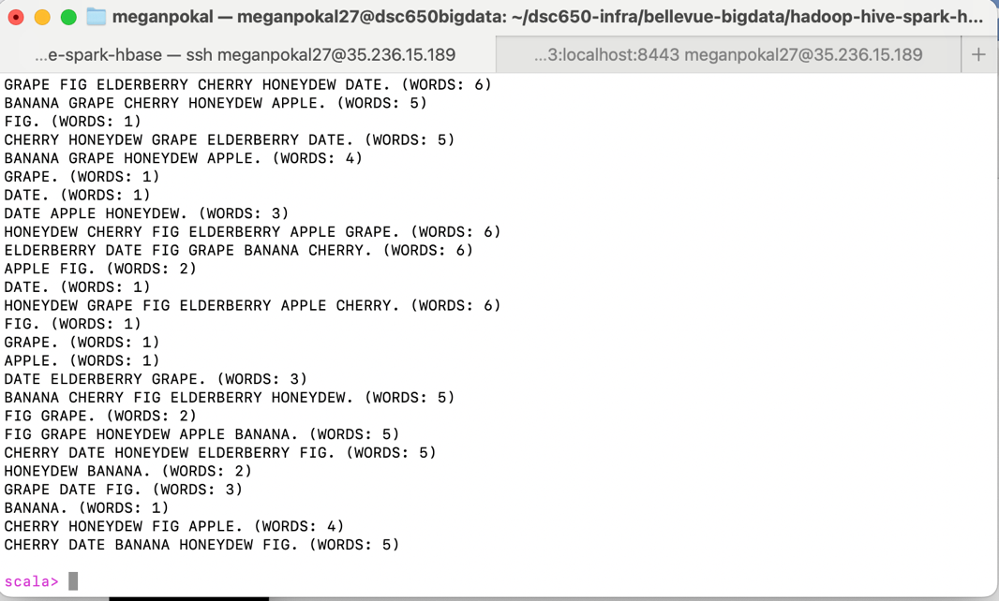

This transformation has converted each sentence to uppercase and adds the number of words in the sentence. The output also shows that Spark created a new RDD using a map transformation and applied this to each sentence in parallel across the cluster.
Objective 5 – Spark IDE + week4.py Development:

1. Download VS Code

https://youtu.be/XXxFYUCCzhM

Installed Visual Studio Code

2. Install python 3 on your Computer

Downloaded the Python Extension

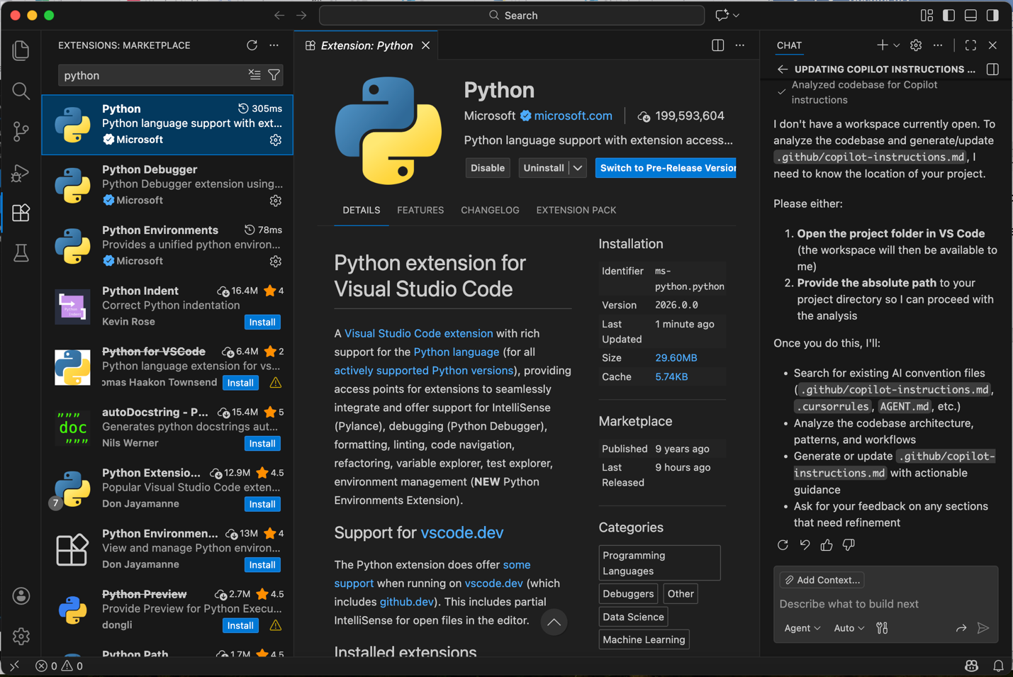

I already had PyCharm installed.

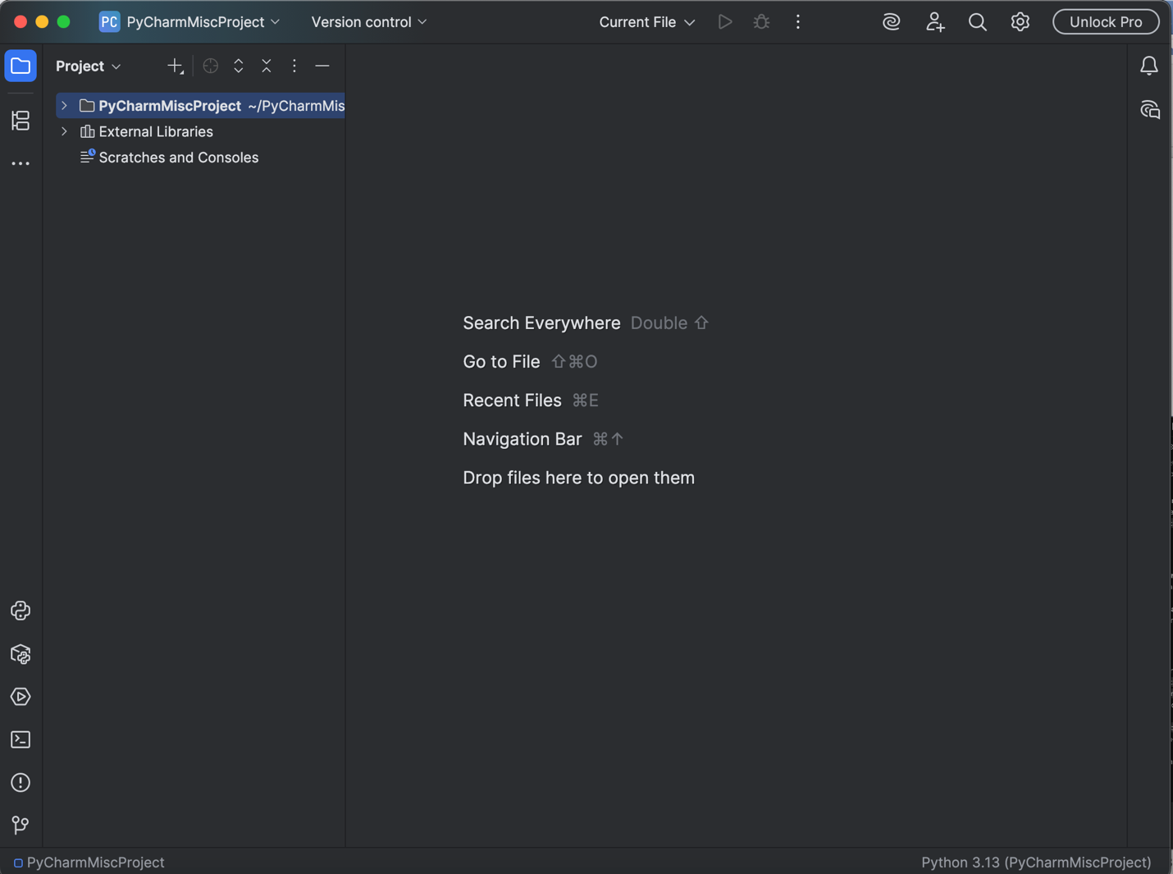

3. Install git on the master container

Create a new git hub repository: bigdata650

https://github.com/mvpokal/bigdata650.git

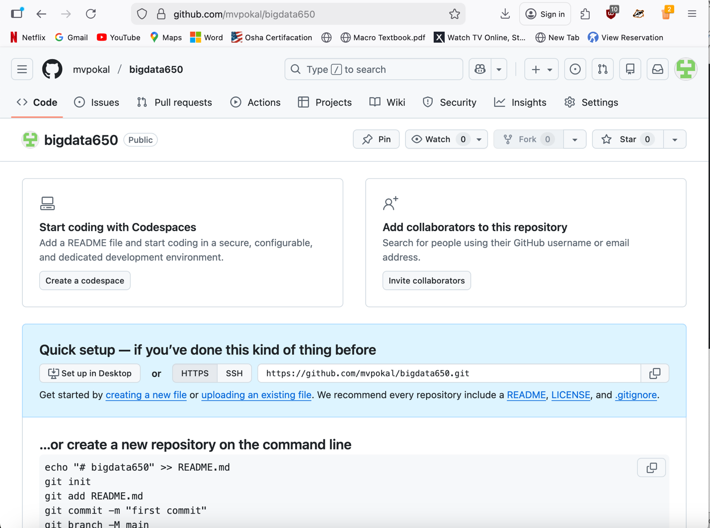

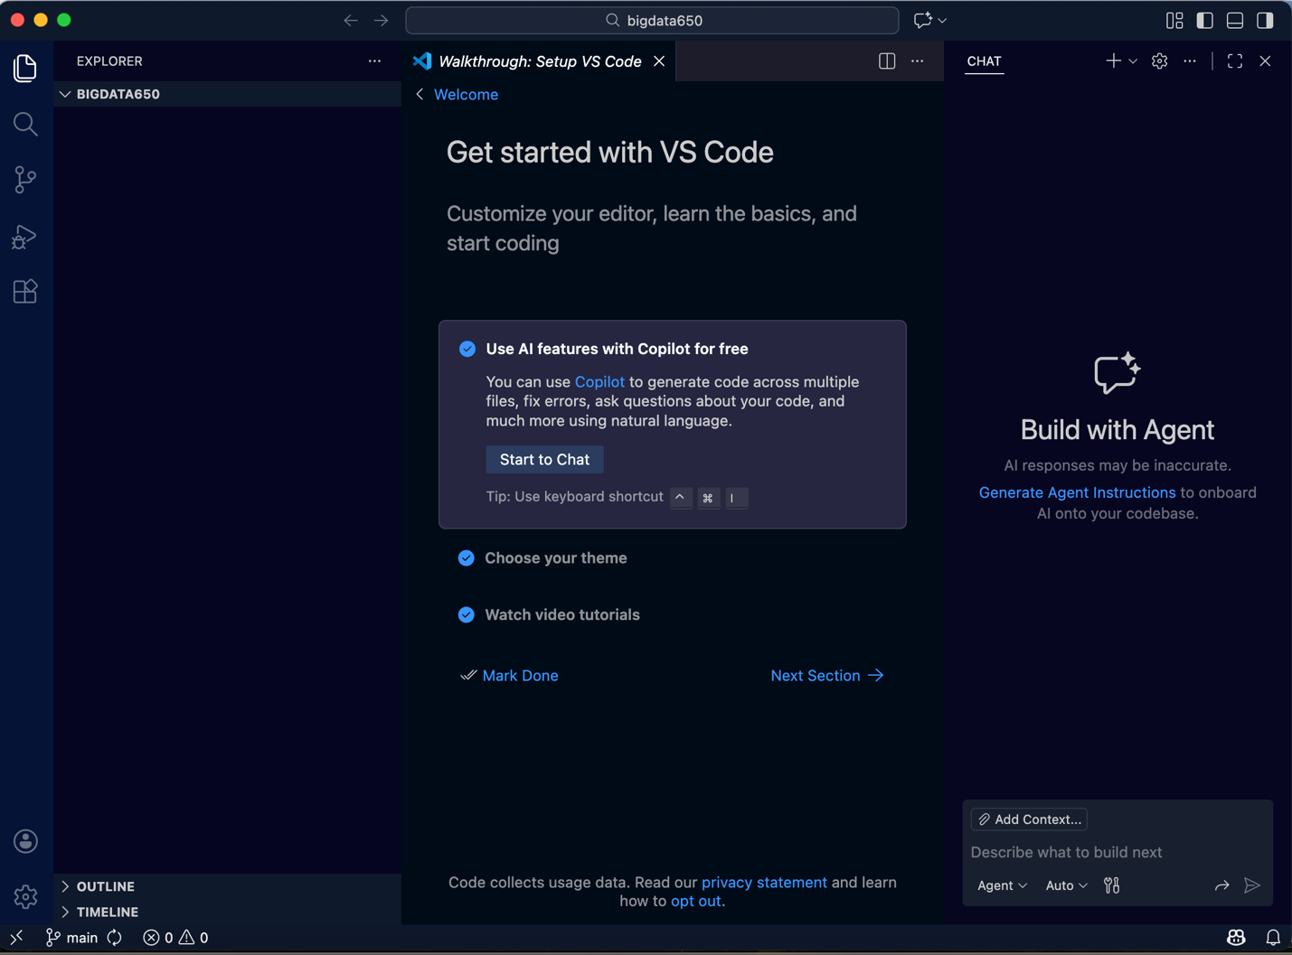

3. The initial week4.py

Created the new folder.

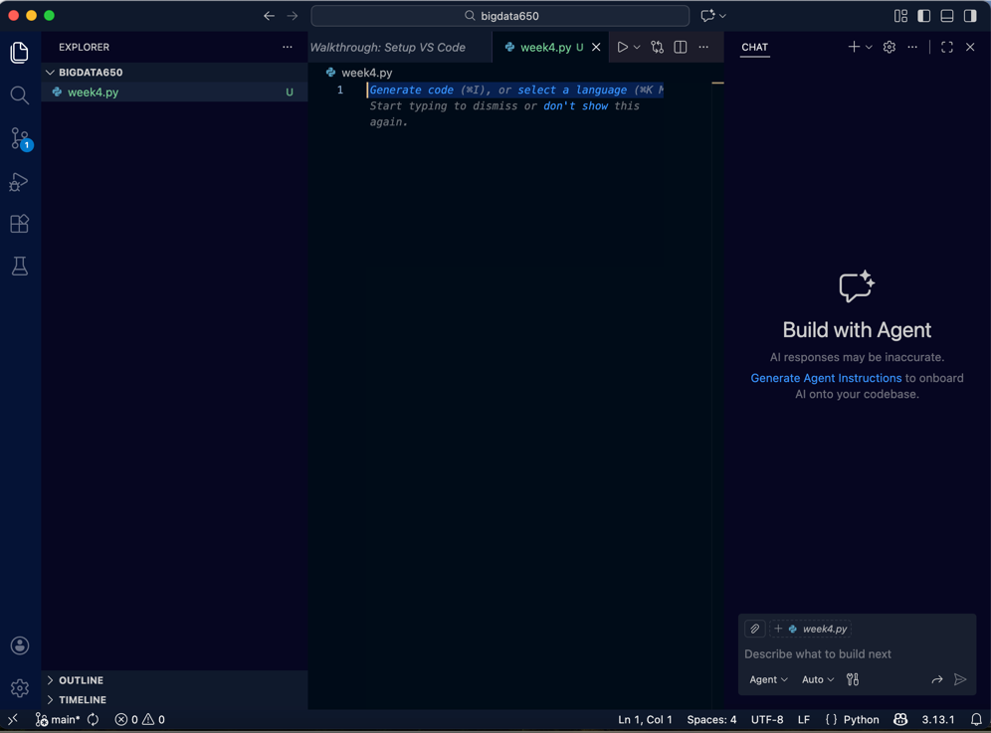

Enter in code:
from pyspark.sql import SparkSession
import random

# Start Spark
spark = SparkSession.builder.appName("SentenceGenerator").getOrCreate()
sc = spark.sparkContext

# Word list
words = ["apple", "banana", "cherry", "date", "elderberry", "fig", "grape", "honeydew"]

# Generate sentences on the driver
num_sentences = 1000
sentences = [
" ".join(random.sample(words, random.randint(1, 6))) + "."
for _ in range(num_sentences)
]

# Parallelize into RDD
sentences_rdd = sc.parallelize(sentences)

# Transformation (replace with your own logic)
transformed = sentences_rdd.map(lambda s: s.upper())

# Show some results (will go to YARN driver logs in cluster mode)
for line in transformed.take(100):
print(line)

spark.stop()

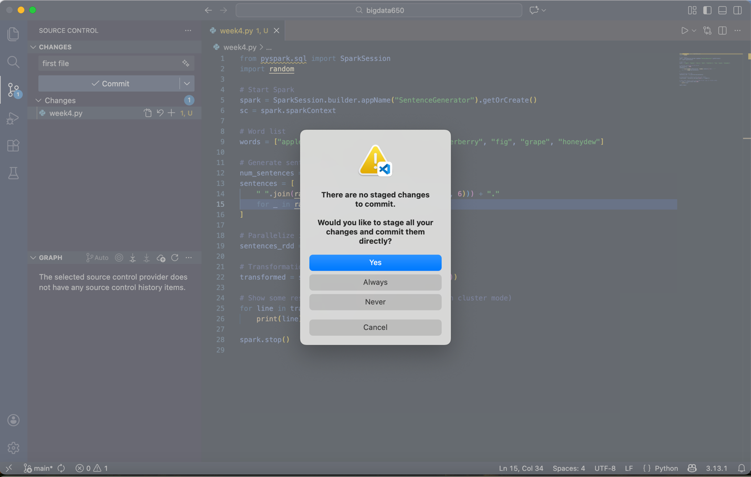

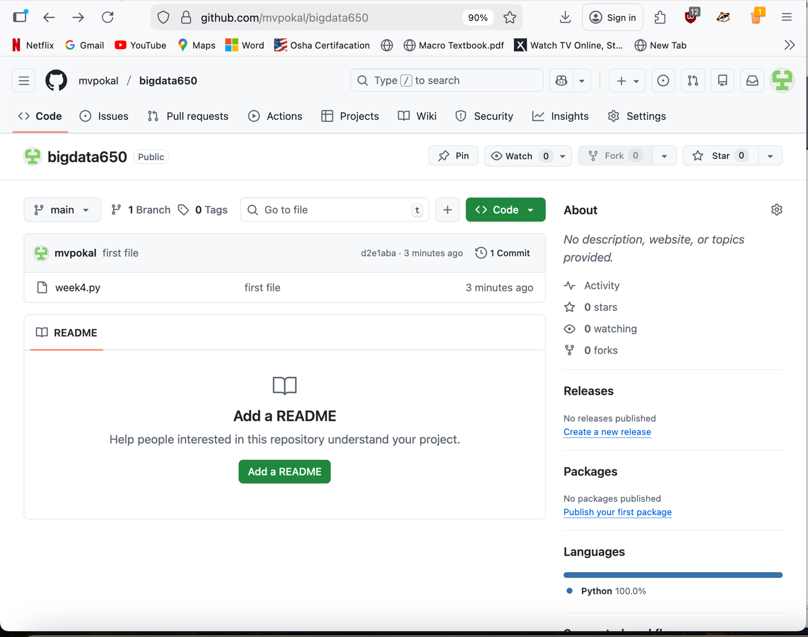
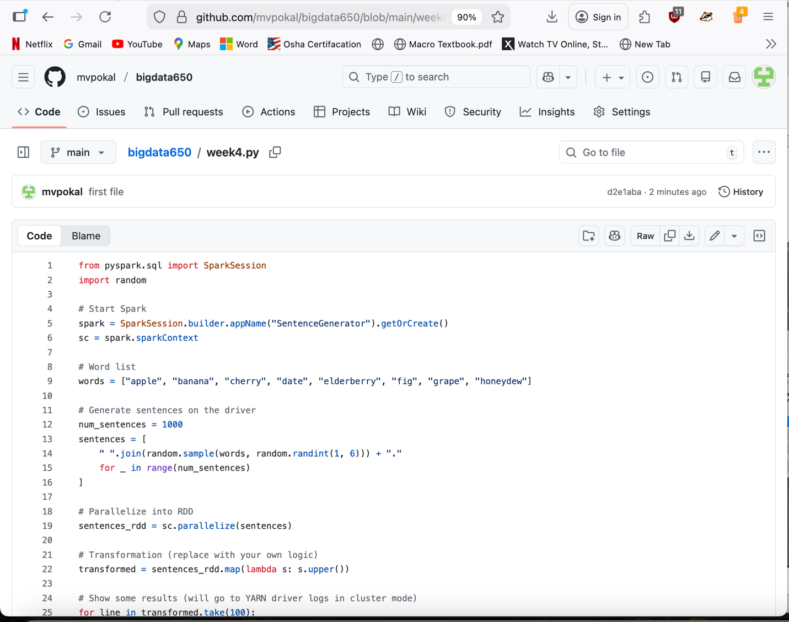

This next part is done in a new terminal because there was an error and I had to do it on a different day.

The first file has successfully saved to the new Git Hub repository.

Next we open the Terminal back up to hadoop-hive-spark-hbase.

docker-compose exec master bash
apk add git
ls
git clone https://github.com/mvpokal/bigdata650.git
ls

For the screenshot below: you will see that it did clone the git hub file bigdata650. I was having trouble with it and was confused, so I made a directory inside of the terminal. So, I had to delete that one with, rm -rf bigdata650, command.
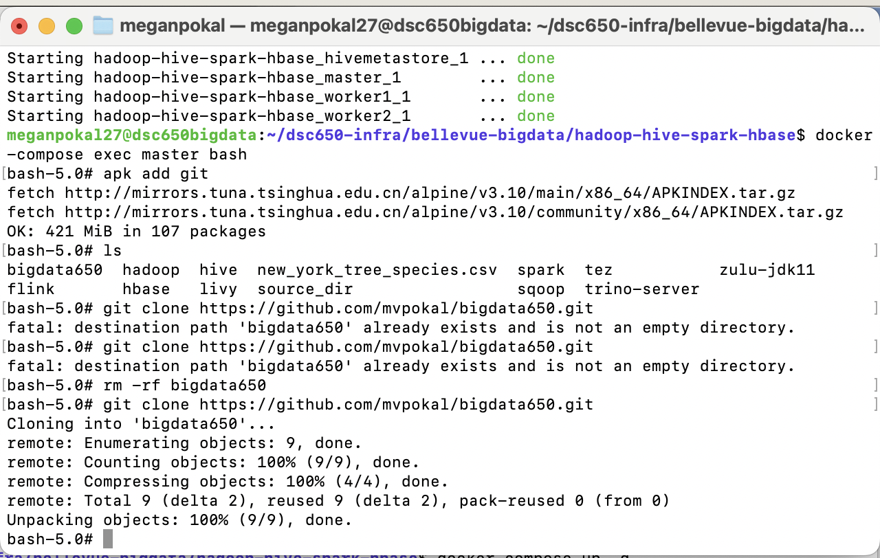

Below is showing the code that was entered in Visual Studio through Git Hub, inside the terminal.
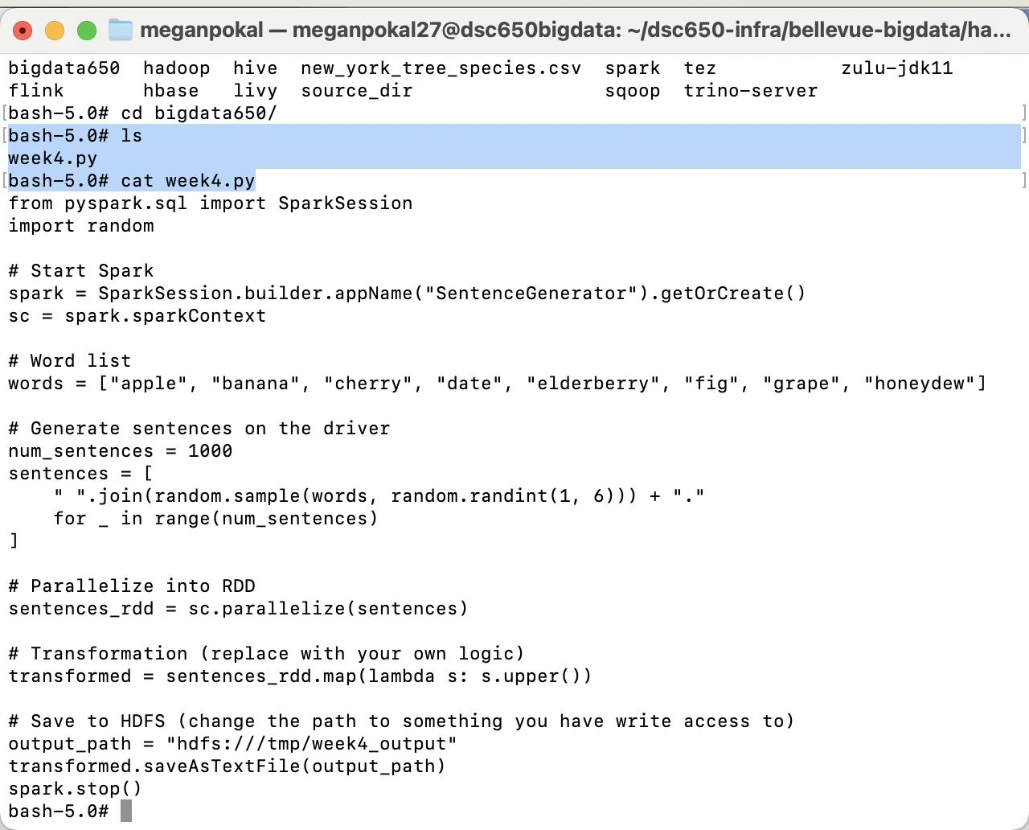

5. Spark Submit Command
spark-submit \
--master yarn \
--deploy-mode cluster \
--name SentenceGenerator \
week4.py
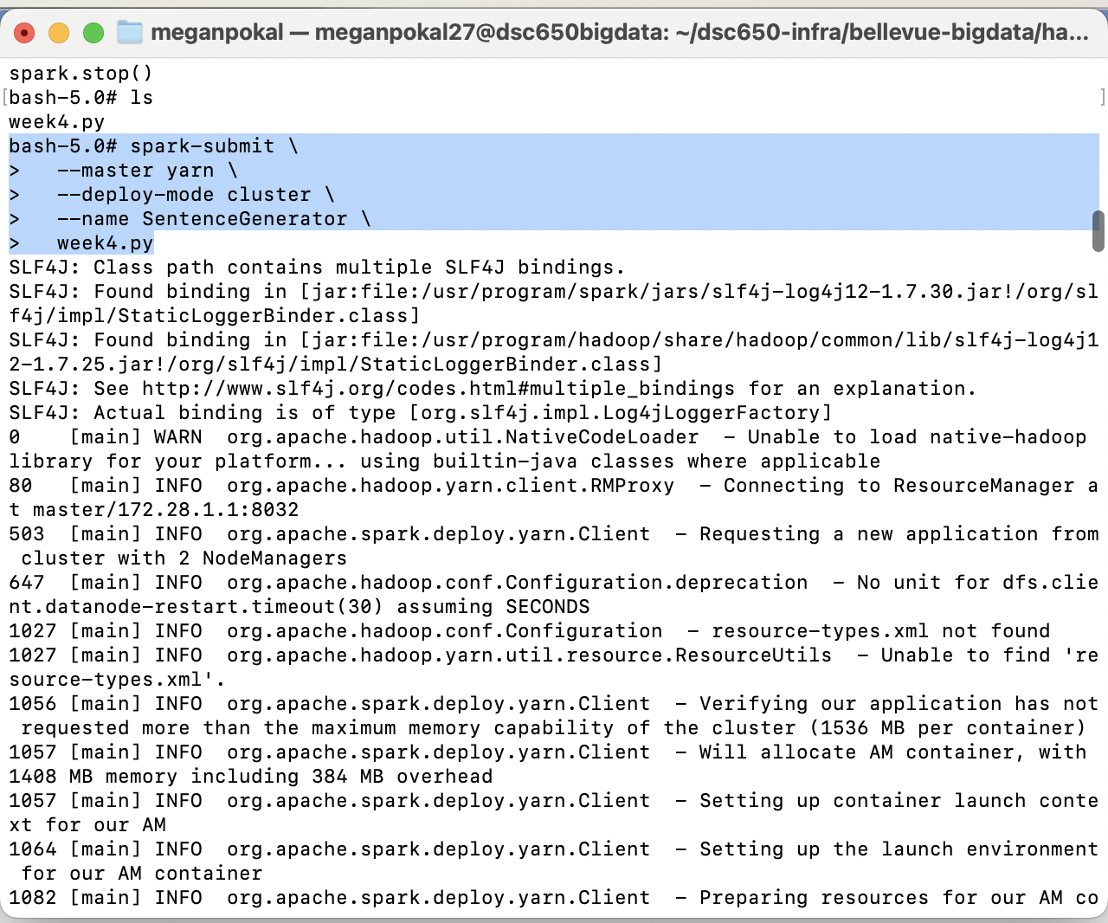

4. The Updated week4.py
from pyspark.sql import SparkSession
import random

# Start Spark
spark = SparkSession.builder.appName("SentenceGenerator").getOrCreate()
sc = spark.sparkContext

# Word list
words = ["apple", "banana", "cherry", "date", "elderberry", "fig", "grape", "honeydew"]

# Generate sentences on the driver
num_sentences = 1000
sentences = [
" ".join(random.sample(words, random.randint(1, 6))) + "."
for _ in range(num_sentences)
]

# Parallelize into RDD
sentences_rdd = sc.parallelize(sentences)

# Transformation (replace with your own logic)
transformed = sentences_rdd.map(lambda s: s.upper())

# Save to HDFS (change the path to something you have write access to)
output_path = "hdfs:///tmp/week4_output"
transformed.saveAsTextFile(output_path)
spark.stop()

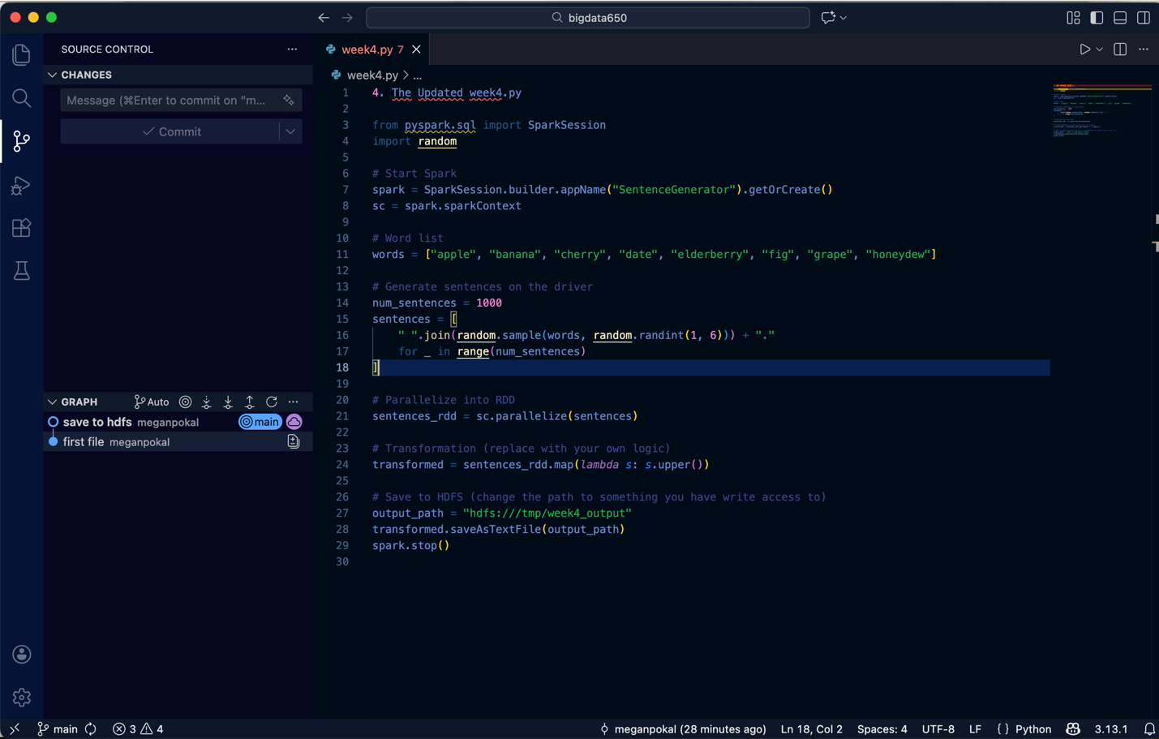

Add in the new code, save to hdfs, sync changes and save to git.

Go back to terminal:

Ls
Git pul

cat week4.py
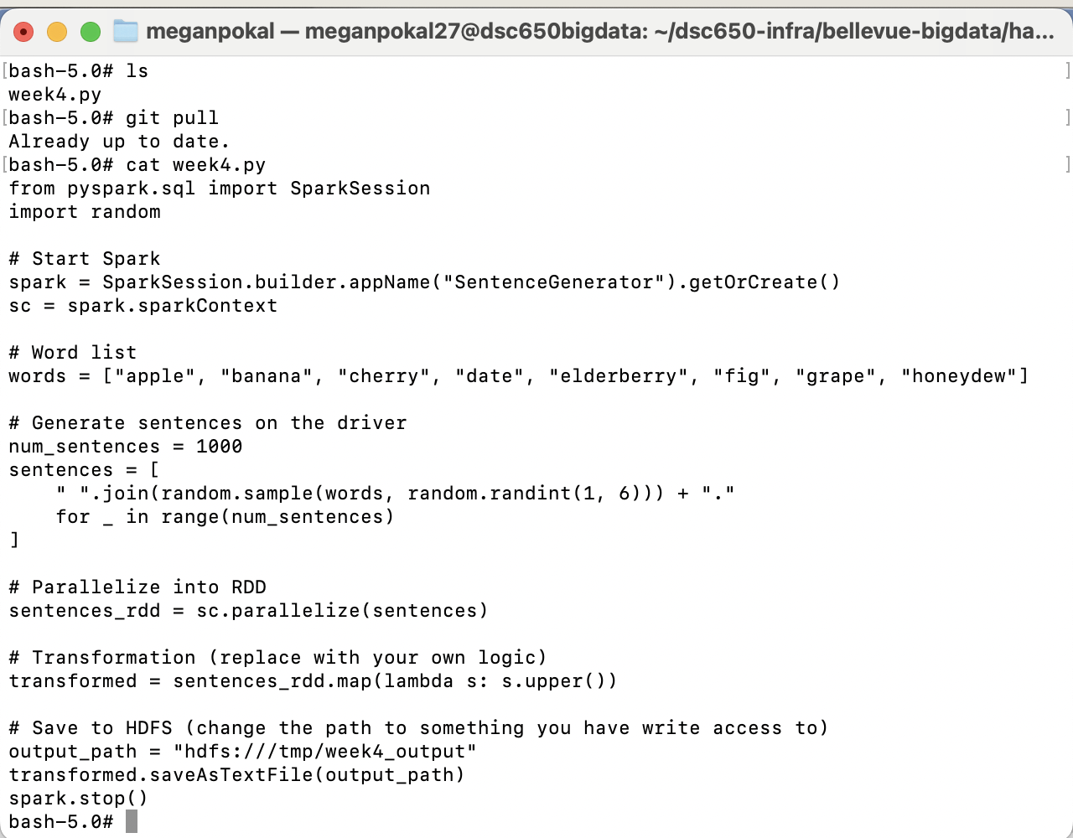

This is showing the full code that is in Git hub.

5. Spark Submit Command
spark-submit \
--master yarn \
--deploy-mode cluster \
--name SentenceGenerator \
week4.py
I am running spark submit again with the updated code.

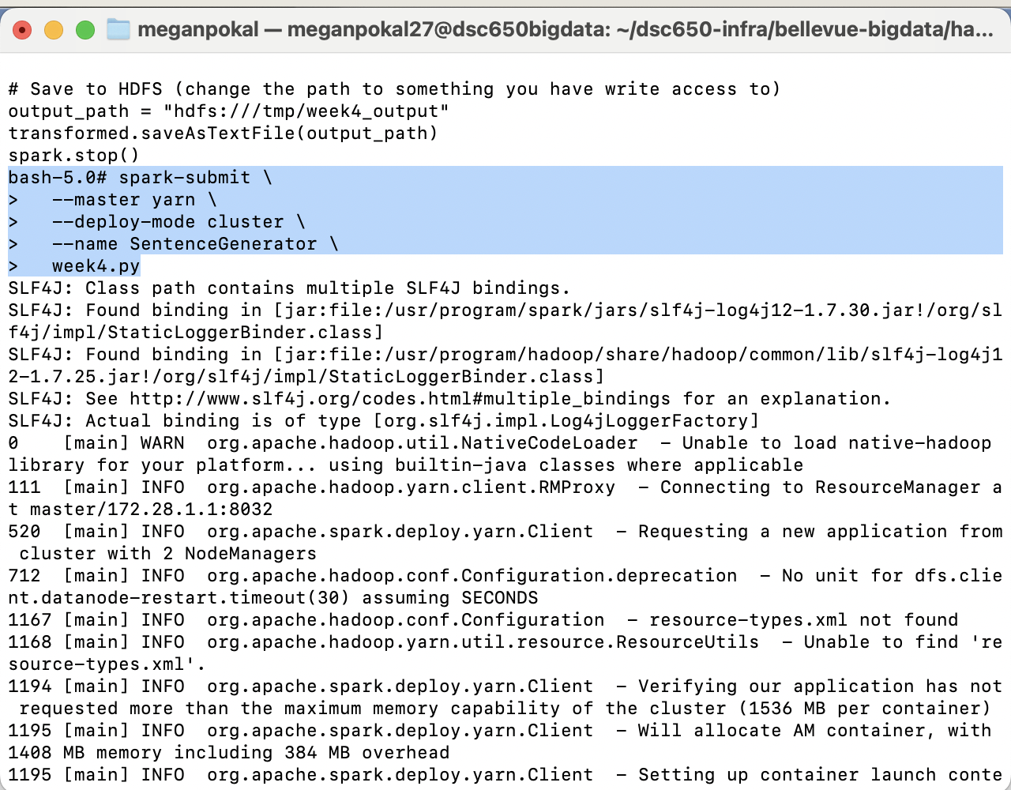

You can see Accepted and Running!!
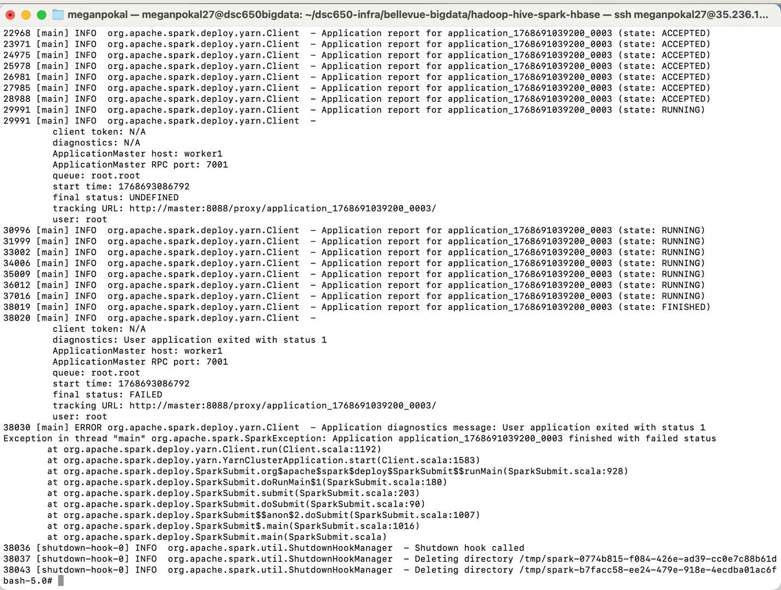
hdfs dfs -ls /tmp

To get the output
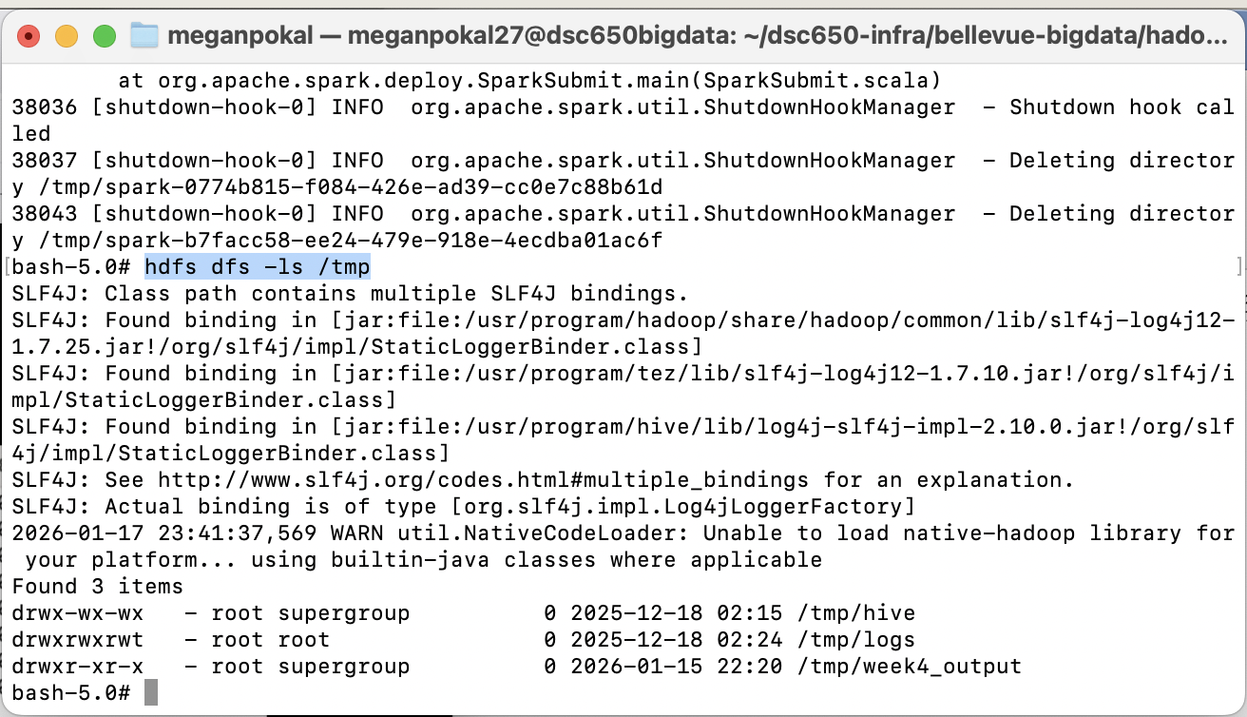

Then list it, hdfs dfs -ls /tmp/week4_output

This shows the output of the directories.
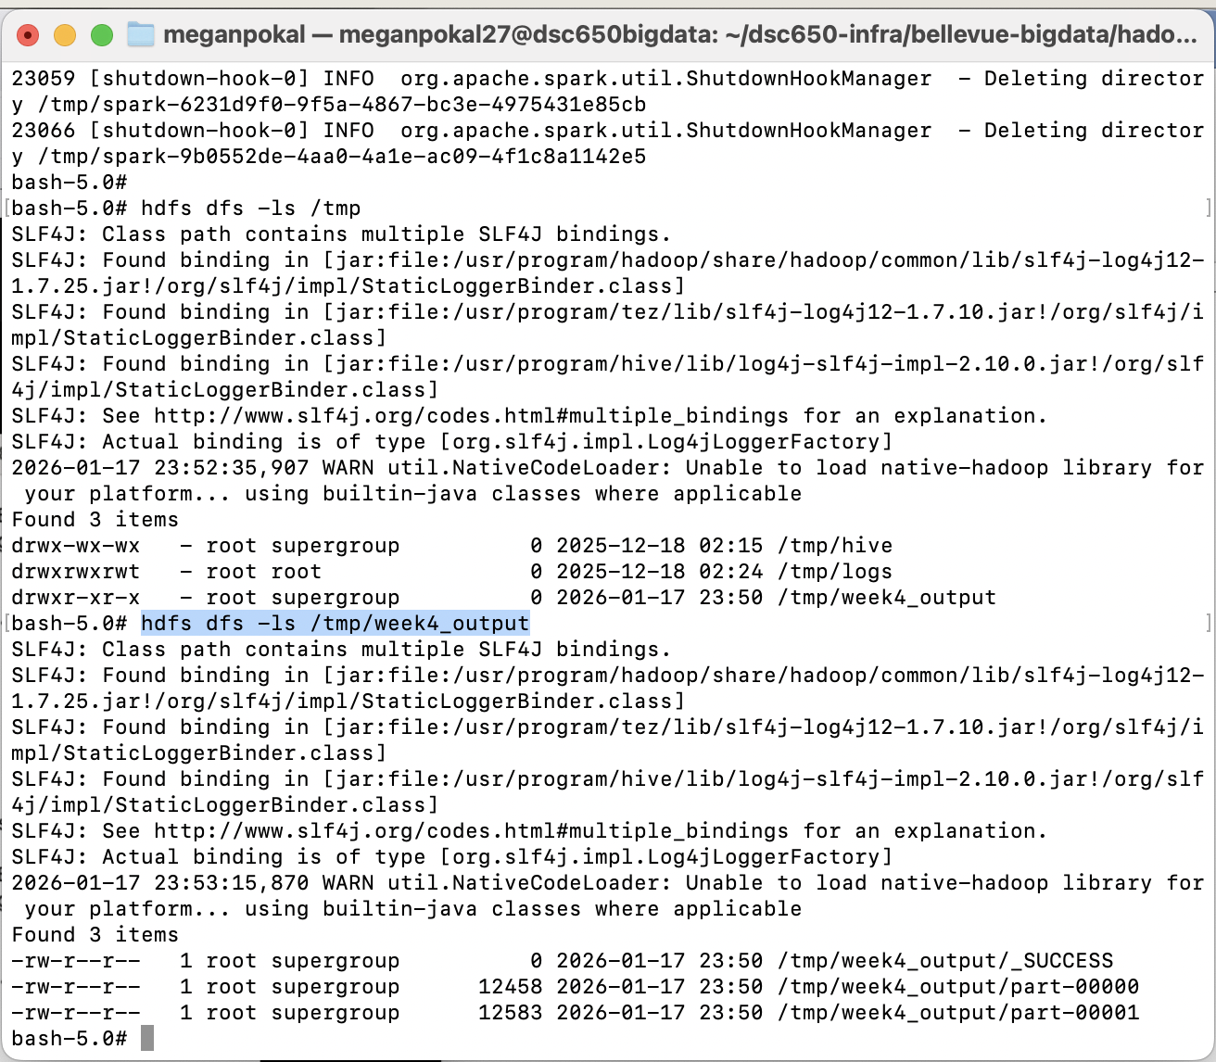

Hdfs dfs -cat /tmp/week4_output/part-00000

Cat: Shows what is in that particular file.
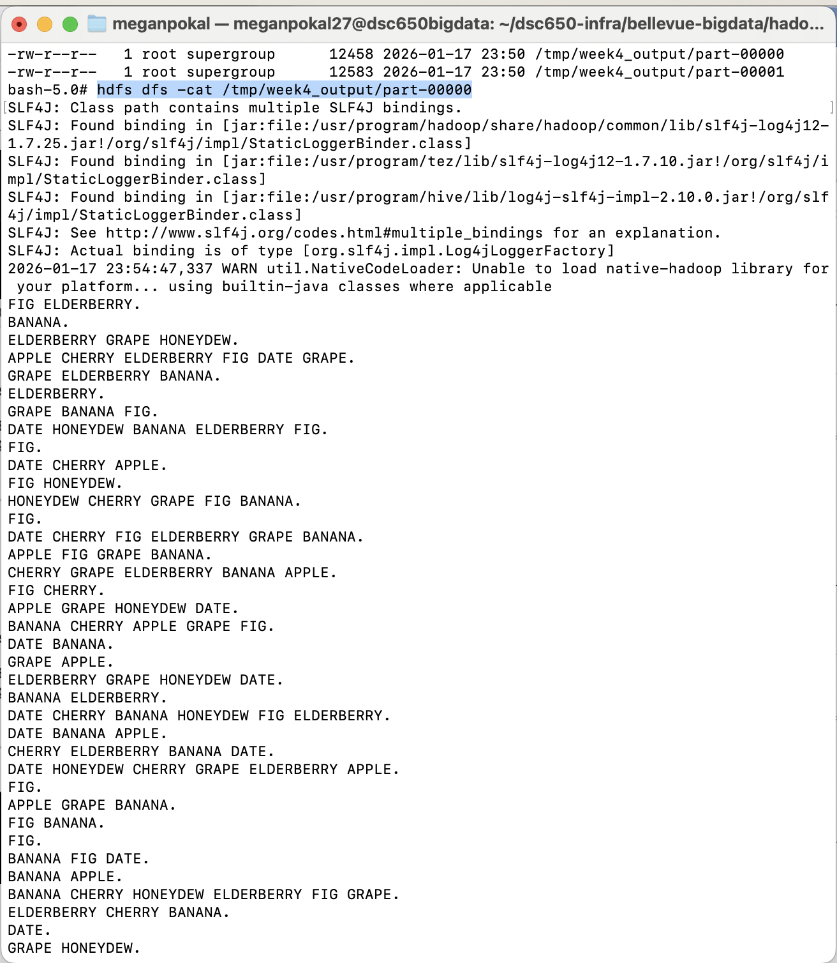

hdfs dfs -cat /tmp/week4_output/part-00001

This shows the output of the second file through Cat.
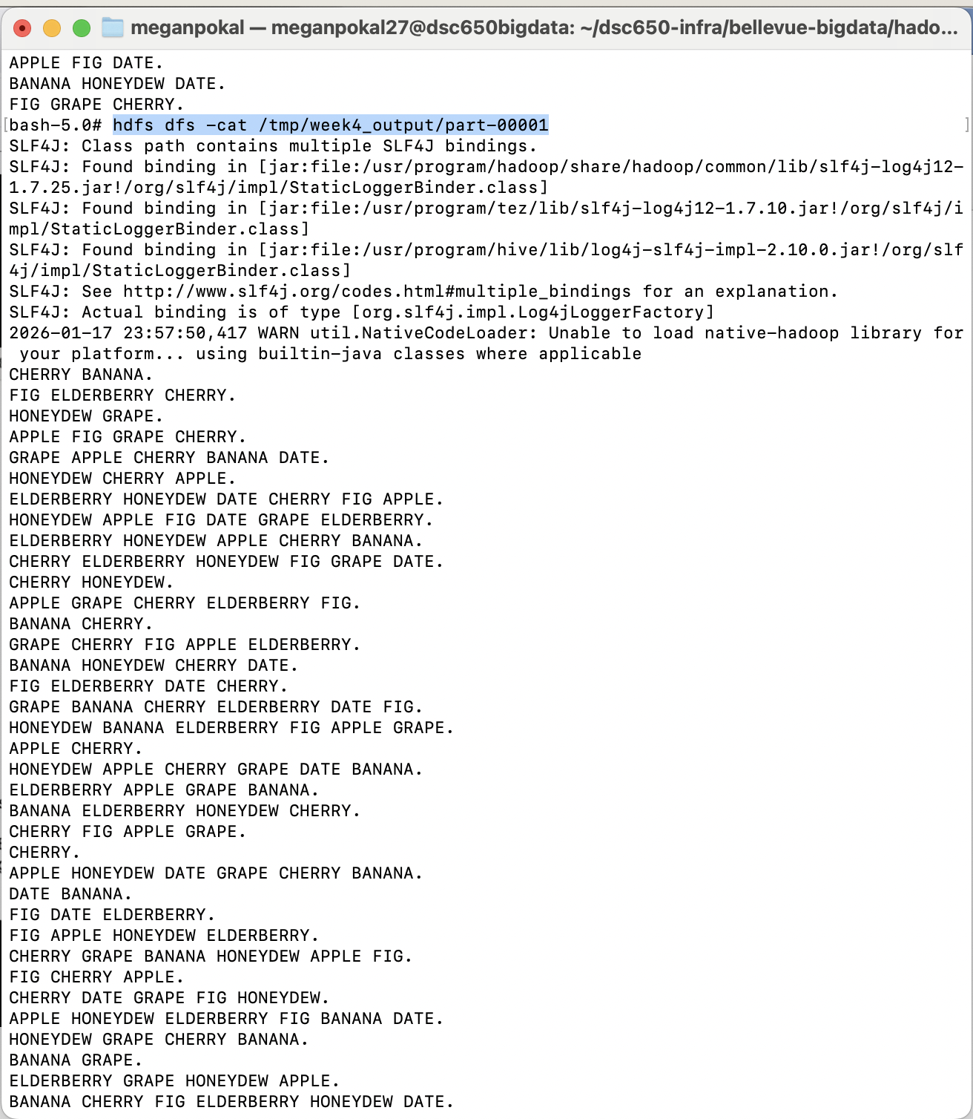

We are going to make changes to our code, push them through GitHub, and then run them through the terminal.

Then Exit out of the terminal and closed the connection in VM Instance.
